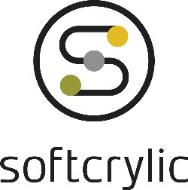**Softcrylic Technology Solutions India Private Limited**

# CIN # U72200TN2002PTC049611

Phone: 044 4255 5580 | Email: info@softcrylic.co.in Website: www.softcrylic.com

**22nd April, 2024**

# **Emp. No SI/2023/929**

**TO WHOMSOEVER IT MAY CONCERN**

This is to certify that **Mr. Thamotharan Chandran** has been working with us as a **Trainee Software Engineer** in **Level 1** since **07th September, 2023** to till date and he is residing at **No: 7, Sri Lakshmi Ganapathi Men’s Hostal, Poomagal 4th street, Poomagal Nagar, Ekkatuthangal, Chennai - 600032.**



**Minneapolis**

718

Washington Ave.N.

Suite 214

Minneapolis,

MN 55401



**Chennai**

Kochar Globe,

th Floor, South Phase,

5

SIDCO Industrial

Estate,

Guindy, Chennai

-

600032.



**Atlanta**

Galleria Pkwy SE

200

,

Suite 1520

Atlanta,

GA 30339



**Princeton**

700

Alexander

P

ark

,

Suite 303

Princeton,

NJ 08540



**Canada**

6000

Boulevard

de Rome,

Suite 410

Brossard,

Quebec

,

J4Y 0B6

This letter is issued at the specific request of the employee, without any risk and responsibility on the part of the company or the official signing this letter.

Yours Sincerely,

For Softcrylic Technology Solutions India Private Limited.

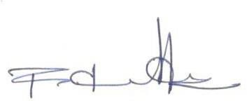

Kirubakaran Rajasekaran

**Senior Manager - Talent Acquisition**